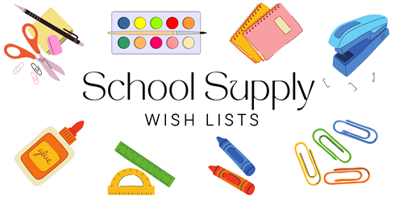

**1st GRADE**

**24/25**

**PERSONAL ITEMS – LABEL WITH CHILD’S NAME**

2 PLASTIC POCKET FOLDERS WITH PRONGS (1 RED & 1 BLUE)

1 PLASTIC PENCIL BOX (8.5” x 5.5” x 2.5”)

1 PAIR OVER THE HEAD HEADPHONES (QUALITY)

1 PAIR FISKARS 5” BLUNT TIP SCISSORS

2 LANYARDS WITH ID HOLDERS

**CLASSROOM ITEMS – DO NOT LABEL**

1 COMPOSITION NOTEBOOK – WIDE RULED – 100 PAGES

1 MEAD PRIMARY COMPOSITION NOTEBOOK – 100 PAGES

1 BOX OF CRAYOLA WASHABLE THICK CLASSIC MARKERS – 8ct

2 BOXES #2 TICONDEROGA PENCILS (SHARPENED)

4 BOXES OF CRAYOLA CRAYONS (24ct)

2 MEDIUM PINK PEAR/CARNATION ERASERS

4 LARGE ELMER GLUE STICKS

1 REAM COPY PAPER

1 BOX KLEENEX TISSUES (110ct)

**GIRLS ONLY:**

1 BOX OF QUART SIZE ZIPLOC BAGS

1 EXPO PACKAGE 4 COLOR CHISEL TIP DRY ERASE MARKERS

1 BOX OF 25 PAGE PROTECTORS

**BOYS ONLY:**

1 BOX GALLON SIZE ZIPLOC BAGS

1 EXPO PACKAGE OF 4 FINE TIP BLACK MARKERS

1 CONTAINER HUGGIES UNSCENTED WIPES (72ct)